Faculty of Computing
Class: BSCS-2023-CD Course: CS-346 Compiler Construction

Lab 01: DFA Simulation
Date: 22, Jan 2026

Lab Instructor: Ms. Urooj Akmal Instructor: Ms. Yusra Arshad

Submitted by:
Abrar butt --- 460297 --- C

Introduction
A Deterministic Finite Automaton (DFA) is a finite-state machine that accepts or rejects strings of symbols from a given alphabet. For every state and input symbol, a DFA has exactly one transition, which ensures deterministic behavior. DFAs are widely used in lexical analysis, pattern matching, and input validation.
Construction of DFA from RE:
https://www.gatevidyalay.com/construction-of-dfa-examples-dfa-solved-examples/

Objectives
- To understand DFA construction from regular expressions and languages
- To implement DFA using:
  - goto/if-else statements
  - switch statements
- To validate input alphabets before DFA execution

Tools/Software Requirements
- gcc / g++
- GNU Make or Visual Studio C++
- Any standard text editor or IDE

Lab Tasks
Below are the tasks students must complete.
Task 1:
Consider the following Regular Expression:

a(bb)*bc
- Draw a DFA for the above RE.
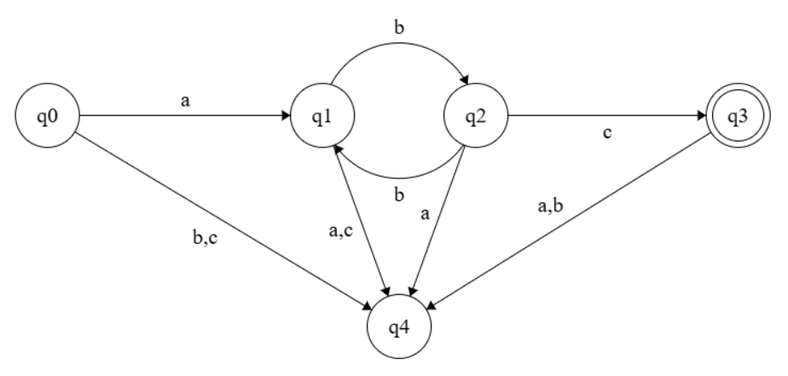
- Determine the language accepted by this automaton

Language accepted by this automaton:
L={a(bb)nbc∣n≥0}

- Implement this DFA in C/C++/Python.
  - Your implementation should validate the input string for alphabet i.e. ∑ = {a, b, c}, before using it in the DFA.
  - Your first implementation of DFA should use goto/if-else statements only.
  - Your second implementation of DFA should use switch statements instead of the goto’s.

Code:
Ln: C++
if-else implementation:

#include <iostream>
#include <string>
using namespace std;

bool validateAlphabet(const string &s) {
for(char ch : s) {
if(ch != 'a' && ch != 'b' && ch != 'c') return false;
}
return true;
}

bool DFA_if_else(const string &s) {
int state = 0;
for(char ch : s) {
if(state == 0) {
if(ch == 'a') state = 1;
else return false;
} else if(state == 1) {
if(ch == 'b') state = 2;
else return false;
} else if(state == 2) {
if(ch == 'b') state = 3;
else if(ch == 'c') state = 5;
else return false;
} else if(state == 3) {
if(ch == 'b') state = 2;
else if(ch == 'c') state = 5;
else return false;
} else if(state == 5) {
return false;
}
}
return (state == 5);
}

int main() {
string inputs[] = {"abc", "abbc", "abcd", "abbbc", "abbbbc"};

for(string s : inputs) {
cout << s << " -> ";
if(!validateAlphabet(s)) {
cout << "Invalid alphabet\n";
} else if(DFA_if_else(s)) {
cout << "Accepted\n";
} else {
cout << "Rejected\n";
}
}
return 0;
}

Output:
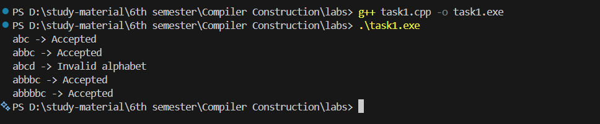

Code:
Ln: C++
switch implementation:

#include <iostream>
#include <string>
using namespace std;

bool validateAlphabet(const string &s) {
for(char ch : s) {
if(ch != 'a' && ch != 'b' && ch != 'c') return false;
}
return true;
}

bool DFA_switch(const string &s) {
int state = 0;
for(char ch : s) {
switch(state) {
case 0:
if(ch == 'a') state = 1;
else return false;
break;
case 1:
if(ch == 'b') state = 2;
else return false;
break;
case 2:
if(ch == 'b') state = 3;
else if(ch == 'c') state = 5;
else return false;
break;
case 3:
if(ch == 'b') state = 2;
else if(ch == 'c') state = 5;
else return false;
break;
case 5:
return false;
}
}
return (state == 5);
}

int main() {
string inputs[] = {"abc", "abbc", "abcd", "abbbc", "abbbbc"};

for(string s : inputs) {
cout << s << " -> ";
if(!validateAlphabet(s)) {
cout << "Invalid alphabet\n";
} else if(DFA_switch(s)) {
cout << "Accepted\n";
} else {
cout << "Rejected\n";
}
}
return 0;
}

Output:
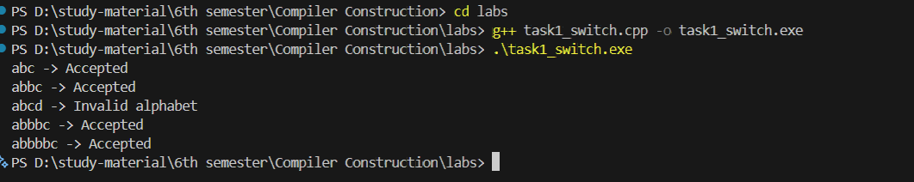
- Test your implementation using the following inputs:

abc, abbc, abcd, abbbc, abbbbc
implemented in above codes….

Task 2:
Consider the following language:
L(M) = {w | w € {a, b}* and contains even number of a’s and b’s}
- Draw a DFA for the above language.
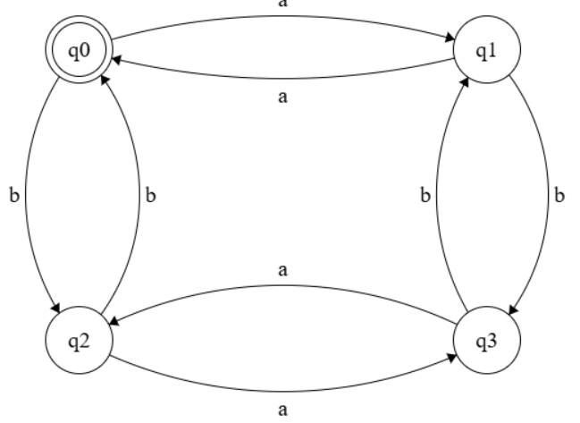
  - Your implementation should validate the input string for alphabet i.e. ∑ = {a, b}, before using it in the DFA.
  - Your first implementation of DFA should use goto/if-else statements only.
  - Your second implementation of DFA should use switch statements instead of the goto’s.
- Test your implementation using the following inputs:

aa, abba, abab, aabbaabb, empty string

Code:
Ln: C++
If else implementation:
#include <iostream>
#include <string>
using namespace std;

bool validateAlphabet(const string &s) {
for(char ch : s) {
if(ch != 'a' && ch != 'b') return false;
}
return true;
}

bool DFA_if_else(const string& s) {
int state = 0; // q0

for(char ch : s) {
if(state == 0) {
if(ch == 'a') state = 1;
else if(ch == 'b') state = 2;
}
else if(state == 1) {
if(ch == 'a') state = 0;
else if(ch == 'b') state = 3;
}
else if(state == 2) {
if(ch == 'a') state = 3;
else if(ch == 'b') state = 0;
}
else if(state == 3) {
if(ch == 'a') state = 2;
else if(ch == 'b') state = 1;
}
}
return (state == 0);
}

int main() {
string inputs[] = {"aa", "abba", "abab", "aabbaabb", ""};

for(string s : inputs) {
cout << s << " -> ";
if(!validateAlphabet(s)) {
cout << "Invalid alphabet\n";
} else if(DFA_if_else(s)) {
cout << "Accepted\n";
} else {
cout << "Rejected\n";
}
}
return 0;
}

Output:
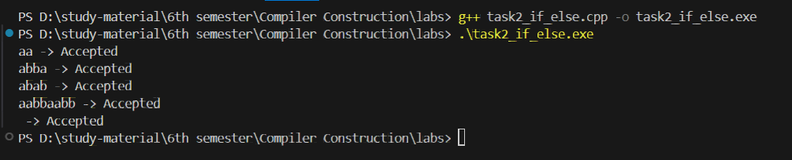

Code:
Ln: C++
If else implementation:
#include <iostream>
#include <string>
using namespace std;
bool validateAlphabet(const string &s) {
for(char ch : s) {
if(ch != 'a' && ch != 'b') return false;
}
return true;
}
bool DFA_switch(const string& s) {
int state = 0; // q0

for(char ch : s) {
switch(state) {
case 0:
if(ch == 'a') state = 1;
else if(ch == 'b') state = 2;
break;

case 1:
if(ch == 'a') state = 0;
else if(ch == 'b') state = 3;
break;

case 2:
if(ch == 'a') state = 3;
else if(ch == 'b') state = 0;
break;

case 3:
if(ch == 'a') state = 2;
else if(ch == 'b') state = 1;
break;
}
}
return (state == 0);
}
int main() {
string tests[] = {"aa", "abba", "abab", "aabbaabb", ""};

for(string s : tests) {
cout << "Input: \"" << s << "\" -> ";

if(!validateAlphabet(s)) {
cout << "Invalid alphabet\n";
}
else if(DFA_switch(s)) {
cout << "Accepted\n";
}
else {
cout << "Rejected\n";
}
}
return 0;
}

Output:
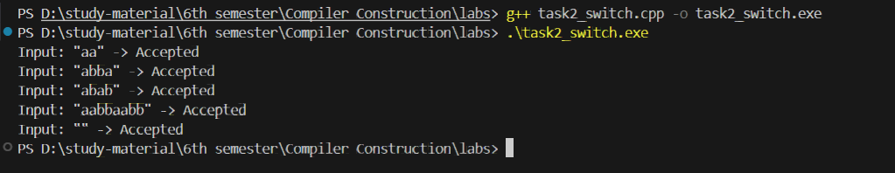

Deliverables
You are required to upload your task (Sources & Word/PDF document) using the link created on LMS followed by a quiz.

